

**THE**

**FORE RUNNERS**

Believe everything is possible

**Degree:** BSc (Honours) Software Engineering

**Stage:** 3

**Batch:** 14.2

**Supervisor:** Mr. Udesh Amarasinghe

**INDEX NUMBER FULL NAME**

10541973 Basura Ratnayake

Gruha Pathi 1.0 - A new frontier in HOME Automation

Domain and Technical Research

# Introduction

The idea chosen for this project is Home Automation, I named the project as Gruha Pathi (GP) meaning House Lord. Gruha Pathi grants convenience, security and freedom for people to manage their house more efficiently.

All electrical equipment, water supply and house protection acts as a unified system that can automatically take decisions based on the information gathered from numerous sensors placed in the house. Electricity usage and total control over all the electrical appliance plugged into the system can be remotely controlled or let the system take decisions based on the information available.

Water flow management is one of the crucial factors that we fail to address in a house for the simple reason that we have plenty of water available in the country 24/7 but that doesn’t mean pure water is forever available in every part of the country. 80% of water used in the kitchen and in cloth washing machines can be filtered and used in toilets with the help of Gruha Pathi.

*“Don’t let a single drop of rain water flow into the sea.”* – King Parakramabahu the Great.

Simply having a CCTV camera system never helps to protect a house from unwanted parties because after a crime has been committed there is very less reason with having only evidence but an automated system that can protect your house from unwanted parties is an ideal solution, with Gruha Pathi this is possible.

Time is a precious commodity that must not be wasted so instead of manually controlling appliances and knowing the usage it is better to be informed by an automatic system. The main key stakeholders of Gruha Pathi are the house owners.

# Domain Research

## Problem Identification

The basic premise of the initial project problem gets defined by evaluating its scope. In the present, the busy life style of an employed individual or a family doesn’t allow them the necessary time to take care of a house or an apartment. This in return results in,

* Electrical equipment not turned off while not using. For an example lights not turned off in the morning, Fans switched On when no one is around and etc.
* Water taps not properly closed.
* House doors and windows not properly closed at night.

When an equipment is not properly used it gets damaged and the same can be said about a house. When things are not properly taken care of, the house owners have to incur a tremendous amount of wealth every month to just to fix the broken things and pay the pay the bills on wastage. More importantly if a burglar happened to enter the premises at night through an improperly closed door or window not only the wealth is in danger but also the lives of the people living inside is also at jeopardy.

## Extent in Determining the Scope

Time is a precious commodity that must not be wasted on tasks that can be automated therefore instead of manually manipulating appliances and determining the usage of those appliance, it is better to be informed by an automatic system that can perform almost all of the tasks performed manually.

For this scenario, the targeted implementation should address to manage the resources and increase efficiency in a potential house by-

* Measures the electrical and water usage from each appliance and then calculate the total usage in order to generate a near approximate payable amount at the end of the month.
* Ability to set a limit in electrical and water usage.
* Ability to control the appliances remotely and let system turn off devices when no one is around.
* Ability to use alternate power systems for electricity appliances in case of a power failure.
* Automatic door and window locking at night and activate security to features to protect against threats.

# Technical Research

## Analysis of Researched Solutions

There are many home automation systems in the world but I focused directly on home automation systems available in Sri Lanka because my implementation will be specifically for Sri Lanka users.

1. **Dialog Smart Home**

Lacks a complete functional system and use independent gadgets from Movinta Group. These components are by far the most advanced devices related to home automation available in Sri Lanka. They use both Bluetooth and an internet connection to command their devices through an android application.

1. **NOSTERS Automation System**

NOSTERS provide commercial applications for industrial complexes and no home automation systems available as of yet. These systems, they provide are all hard-coded systems that are specifically designed for a single complex and the users cannot make any modifications to systems. All modifications have to be made by re-designing the entire system and they consume a huge amount of bandwidth when sending and receiving commands (Cinnamon Grand Hotel, 2008).

1. **HomeTEC Lanka**

They provide no integrated systems, only isolated components that require individual input mechanisms meaning each device has to have a separate input device. They use RF communications to send and receive commands and doesn’t intrude or disrupt the internet bandwidth.

1. **Southern Automation Systems**

They provide custom user specified systems or components but none of the devices are developed by them all of the devices are imported from Danfoss, Satchwell, Frascold, Novus Edge and Tridium. The use extensive amount of internet bandwidth which sometimes disrupt the internet connection.

## Evaluating the Problem Scope

1. Exploring different types of available home automation systems according to the problem parameters, it’s clear from already available research that only through combining multiple types of advantageous features of those system and inventing new features is the most optimal solution be implemented. To this end, understanding and researching about these heuristics had to be done.
2. An array of devices has to be designed to manipulate the workings of the house allowing the system and the users to-
   1. Turn ON/OFF electrical appliance.
   2. Turn ON/OFF water supply.
   3. Activate/Deactivate house security features.
   4. LOCK/UNLOCK doors and windows.
   5. Provide usage of appliance to the system every hour.
3. A central hub has to designed to gather details and provide commands to each device according to commands updated in the central database.
4. A web API has to be developed to upload and download data from and to the central database.
5. An android application and a desktop application has to be developed to let users interact with the main hub to give commands and get appliance usage data.

# Method of approach

This circuit is the corner stone of the entire system. With the above mentioned research I arrived at the conclusion that the communication between these devices will be RF (Radio Frequency) based which save internet bandwidth.

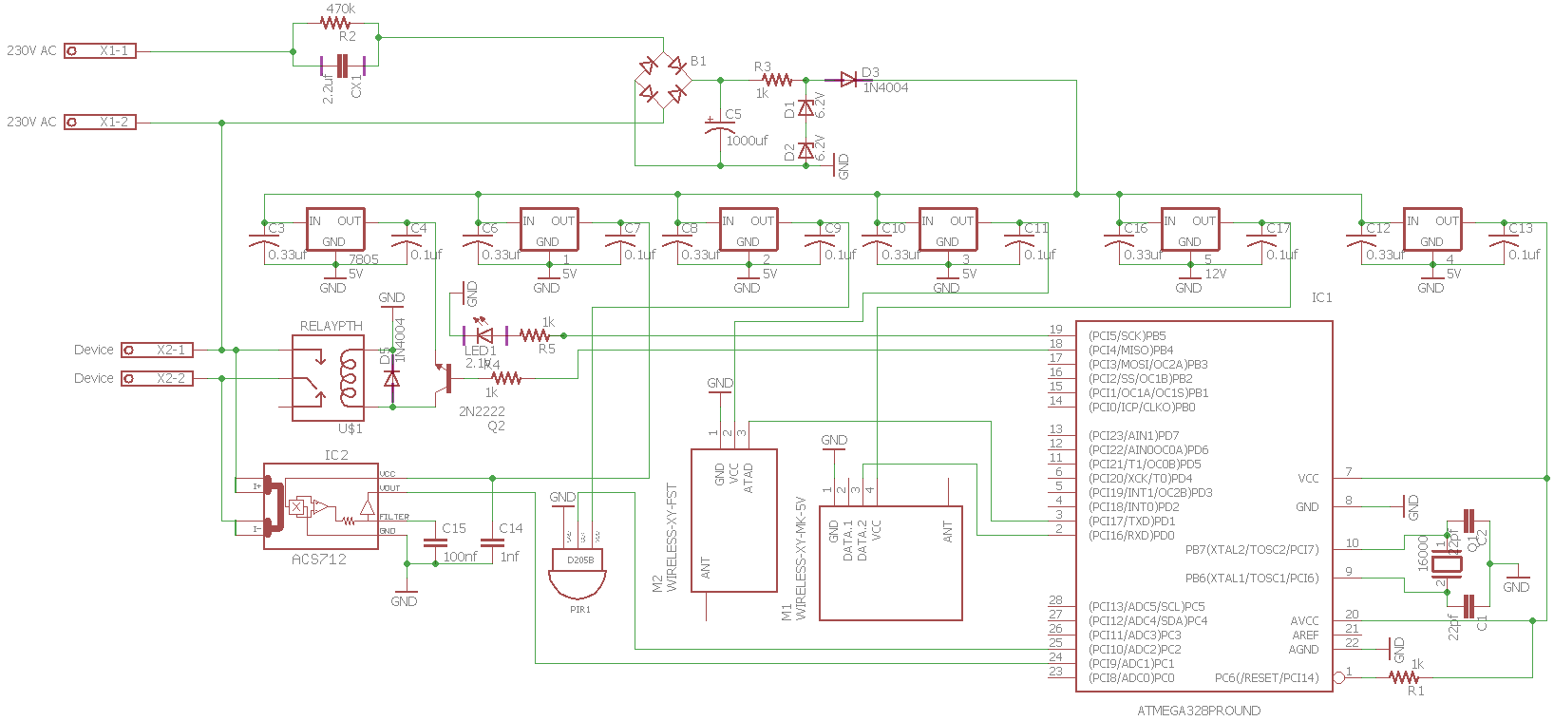

Figure 1 – Switch, Power Socket Circuit

## Workings of the Circuit

1. **Voltage Transformation**

Transforming 230V AC (Mains) to 5V and12V DC (Variable Outputs) with 1 amp posed a great challenge. To transform Mains to Variable output required an electrical transformer which was large in size, I fixed this issue by using capacitor based transformation and use voltage regulator ICs to obtain 12V, 5V DC respectively.

1. **Wireless** **Communication**

RF 433MHZ wireless communication (RF Modules) is used to receive and transmit data and commands to and from devices. The issue faced here was the initial range of RF module transmission distance which was 12cm, after much research managed to solve it by using a signal booster and a 17cm long antenna.

1. **Size of Components**

With the circuit prototype testing it became evident that size of the devices has increased by 20% in comparison to the initial planned component size. The solution for this issue would be to use SME (Surface Mounted Electronic) but I have no experience with them as of now, I plan to gain knowledge on the subject.

1. **Size of Memory**

The storage capacity of ATMEGA328-PU is 32KB which is not enough to store all the planned functionality of the device therefore in order to solve the issue I used ROM IC 24c64 which contains a capacity of 32 KB the resulting storage capacity is 64KB (ATMEGA328-PU + 24c64).

## Main Circuit Components in Detail

### Communication Modules

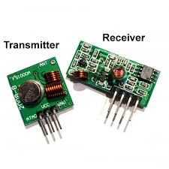

Figure : RF 433 MHz

**Transmitter**

Frequency Range: 433.92MHz

Input Voltage: 3-12V

Transmission Range: 7cm but with 17cm Antenna 700m

**Receiver**

Frequency Range: 433.92 MHz

Modulation: ASK

Input Voltage: 5V

### Micro-Controller IC

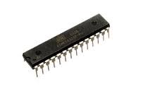

Flash:32 kBytes

Pin Count:32

Max. Operating Freq. (MHz):20 MHz

CPU:8-bit AVR

Max I/O Pins:23

Figure : ATmega328-PU

**Voltage Measure IC**

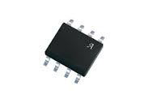Input Voltage: 5V

Measure Voltage: 230V 30A

Bandwidth: 80 kHz

Figure : AC712 30A

**Motion Sensor**

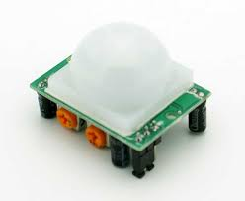Input Voltage: 3-15V

Signal Output: ≥3500mV

Sensitivity: ≥3300V/W

Figure : PIR Sensor

# Reference

1. Nosters World. Available at: <http://www.nostersworld.com/Building-Automation.php>
2. Movinta Group. Available at: <http://movintagroup.com/futuretech/smart-home-appliances/>
3. SAS Lanka. Available at: <http://www.saslanka.com/services>
4. HomeTec Lanka. Available at: <http://www.hometeclanka.com/computer-controlled-switches.html>
5. Nikini Automation. Available at: <http://www.nikiniautomation.com/>